Chapter 7, Problem 70.

Determine v_{o} for t > 0 when v_{s} = 20 mV in the op amp circuit of Fig. 7.135.

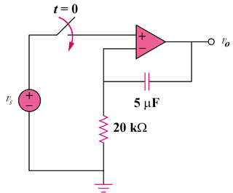

Figure 7.135
For Prob. 7.70.

